School User Accounts

Use these steps to create CIF Home accounts for School Admin or Coaches.

Find “User Manager” by hovering over “School Settings” on the left navigation.

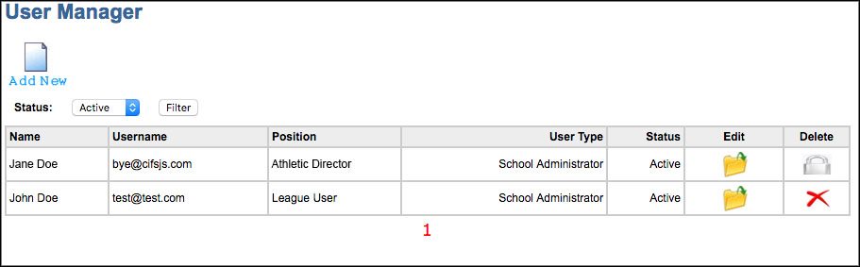

On this page you will see all the Users who have access at your school.

Add New Account
To set up a new account, click “Add New”.

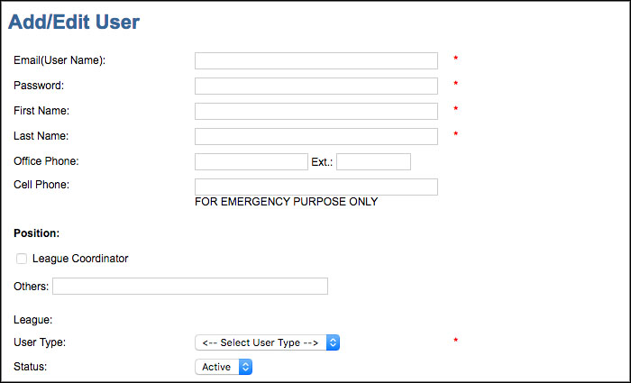

- The Email (Username) should be a valid email address for the account holder.
- Give this User a temporary password and ask them to change it when they login.
- Cell Phone will not be published. It will only be used in the case of an emergency if the section office needs to reach you.
- User Types: School Admin vs School User
School Admin should be reserved for Principals, Athletic Directors, AD Assistants, Accounting Clerks etc.
School User would be given to coaches or those who need limited access.

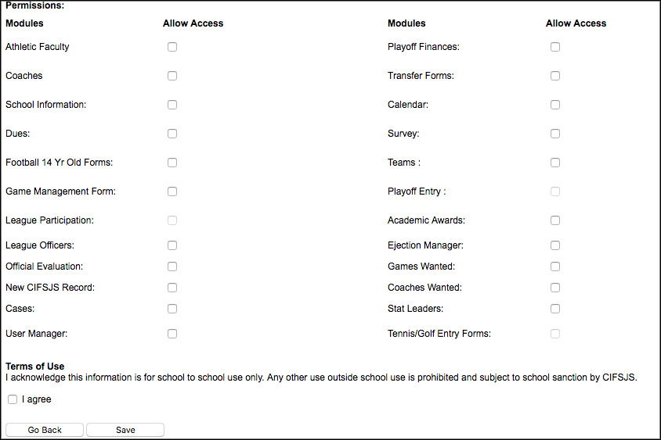

Under Permissions, you will check off the features you would like to give this User access to. You will notice that these permissions match up with the items on the left navigation bar.

Delete an Account

If you see a lock next to the account that means that User has taken some sort of action on their account. For records and auditing purposes we cannot completely delete the account.

Instead, we can set the status to “Block” which will block their access completely.

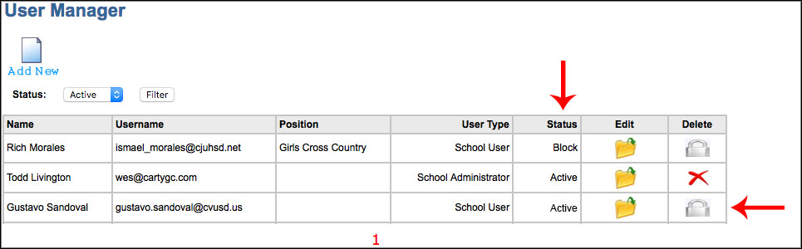

Updating the Directory

Follow the steps below if you need to update your CIF Directory page after the initial start of year Directory has been completed.

Athletic Faculty
Find “Athletic Faculty” by hovering over “School Settings”

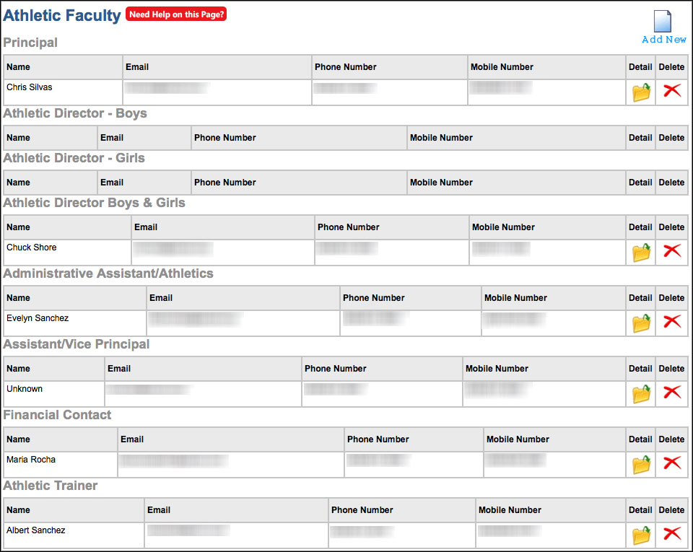

- Changes that you make to the Athletic Faculty on this page will be reflected on the CIF Directory.

Coaches
Change coaches on the CIF Directory by going to “Teams”, selecting the sport, and “Add/Edit Coaches” under the Coaches section on the right hand side.

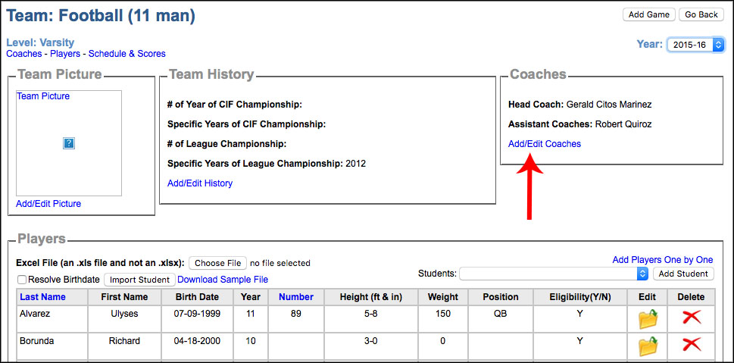

If you do not see your coach listed on the dropdown menu, you will need to add them on the Coaches page (School Settings > Coaches).

